Natural Disasters Intensity Analysis And Classification Using Artificial Intelligence

|  |  |
| --- | --- |
| Date | Z5-11-ZO2Z |
| Team Id | PNT2022TMID30264 |
| Project  Name | Natural Disasters Intensity Analysis And Classification  Using Artificial Intelligence |

Configure Image Data Generator Class

Image Data Generator

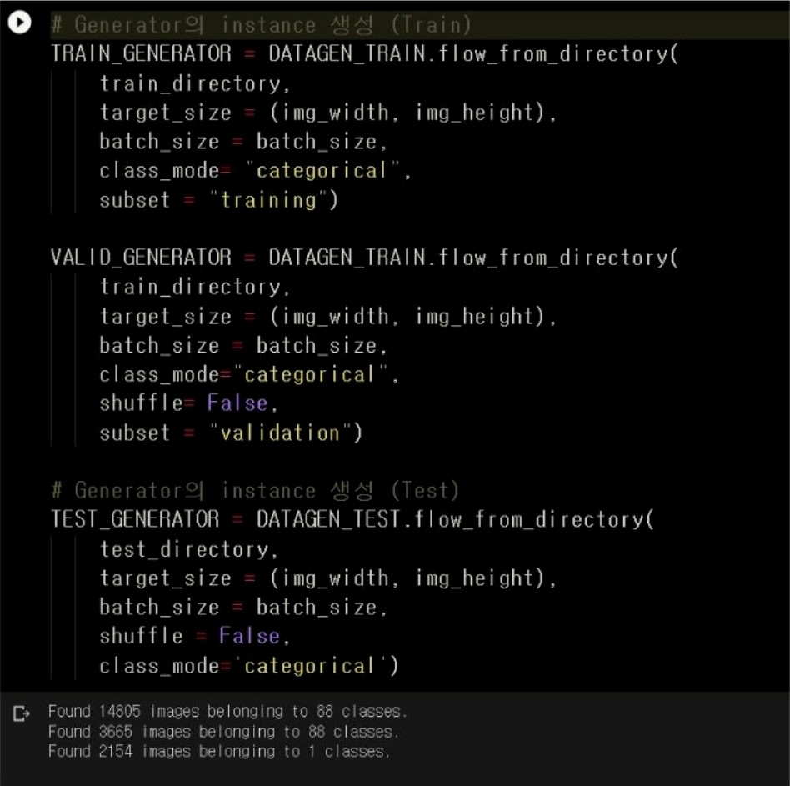

Configure Image Data Generator Class

* configure image data generator class
* data_generator.py
* from keras.preprocessing.image import ImageDataGenerator
* from

tensorflow.keras.applications.vgg19 import preprocess_input

* train_datagen ImageDataGenerator(dtype='float32',
* preprocessing_function=preprocess_in
* test_datagen ImageDataGenerator(dtype='float32',
* preprocessing_function=preprocess_in